History of Nordic Patrol
at Mt. Rainier National Park

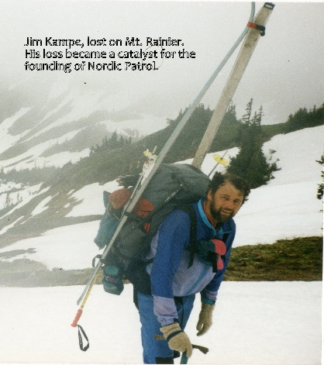
1990 – On Sunday, October 28, Jim Kampe was lost while skiing the Muir Snowfield with friends. Jim was a member of the Washington Ski Touring Club, the Sierra Club, and the Seattle Mountaineers. Members and friends joined Rangers in the unsuccessful multi-day search for Jim. He was 38.

Greg Woodman, then President of the ski club, recalls:
“I had planned to go on that trip, but couldn’t make it. The next WSTC meeting was that Thursday. I had to announce that Jim Kampe was missing from that Sunday outing. Many Club members were still down at Rainier searching that Thursday. That’s when Stan Davis came up with the idea of Nordic Patrol.”
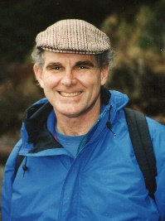
1991-92 – Washington Ski Touring Club Officer Stan Davis worked with Mt. Rainier National Park administrators to find a way to improve search and rescue operations within the Park. The result was Nordic Patrol, a volunteer program to enhance the safety of winter visitors in the backcountry. Teams of Nordic Patrollers would tour the trails and slopes around Paradise performing "preventive search and rescue" – marking safe trails and helping the public stay found. In emergencies, Patrollers would engage in the search and rescue of lost or injured visitors.

1992-93 – WSTC launched the volunteer Nordic Ski Patrol at Mount Rainier.

Alice Walter, a founding Patroller, says:
Founding Patrollers:
Stan Davis
Dianne Carreri
Deborah Dickstein
Virginia Miller
Gordon Thomson
Hugh Shane
Alice Walter
Michael Ward
Dan Weinstein
Lee Wilcox
Greg Woodman
and others
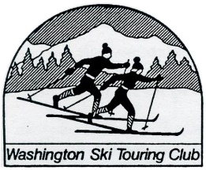
“It was epic to begin such a needed service, considering what Stan and the others went through losing Jim on the Mountain. David and I were supposed to go on that trip, and we didn’t go; we’ll always wonder if our presence might have changed the outcome. I know I felt maybe I could make a difference through Nordic Patrol for some other person—change the outcome for them.”

2017 – Twenty-four years after its founding, Nordic Patrol spun off and became a chapter of the National Ski Patrol. In partnership with the National Park Service, Nordic Patrol now offers a variety of winter skills training opportunities to enhance the safety of volunteers and park visitors. WSTC remains pivotal in the program. One out of three Patrollers are WSTC members and WSTC provides generous financial support.

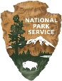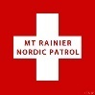

Mt. Rainier Nordic Patrol Jan 2018

